ESO204A-Fluid Mechanics and rate processes
Tutorial 1
Date: 02/08/18
Note: Tutorial problems are from 7th edition of the textbook.
- P1.56
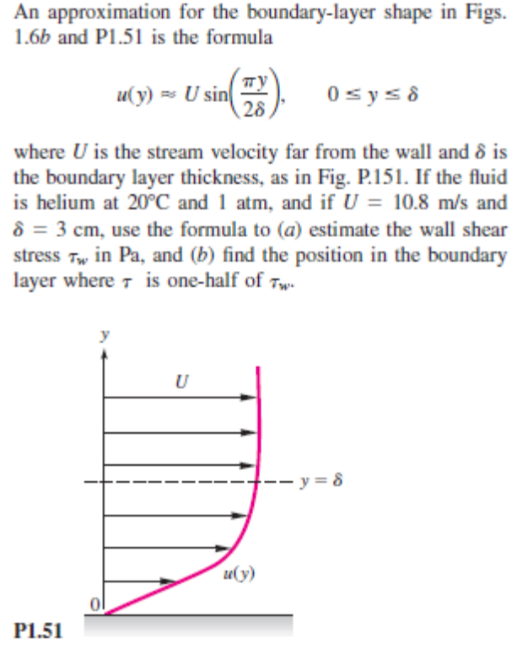

- P1.57
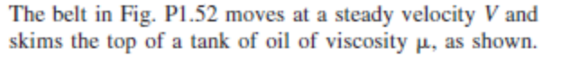
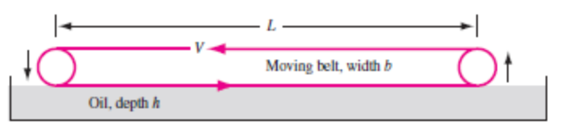
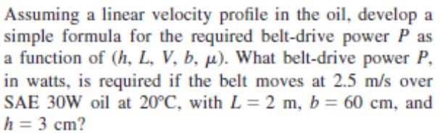

- P1.58
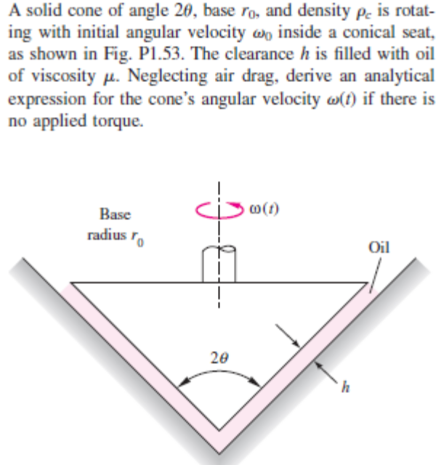

- P1.59
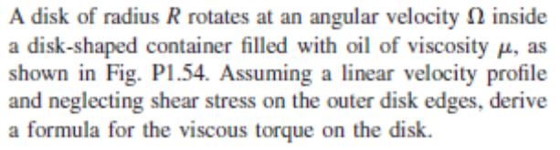

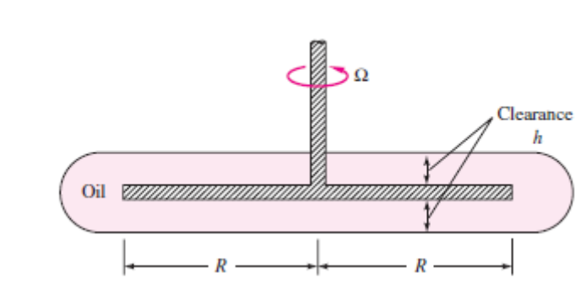
- P1.61
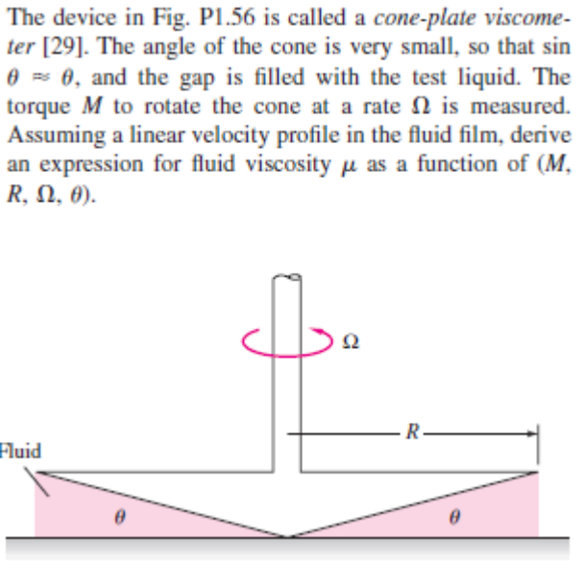

- P1.62
